**Product Build Service Test**

<http://sc-css-wb-02-vm/dev2/ik/view5/css_web/cmweb/services/cmweb.srvc.pbuild.php>

2/2/2018

1.Different colors for pre and post?

2. Update the legend: red triangle; *; down arrow.

3.

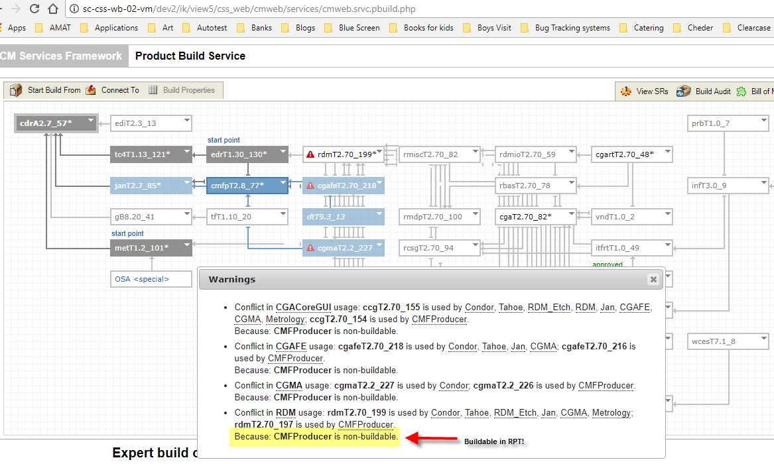

4. RPT::CM::Build order – change the column name from “Build Required” to “Buildable”.

5. pmT5.8_39 – OK.

6. dap2.7_1 - OK: